31 How to stay productive and focused while working from home? Please highlight the important words to the semantic meanings in every sentence using boldface fonts.

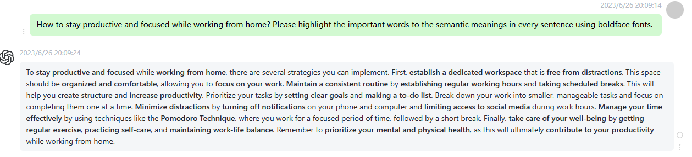

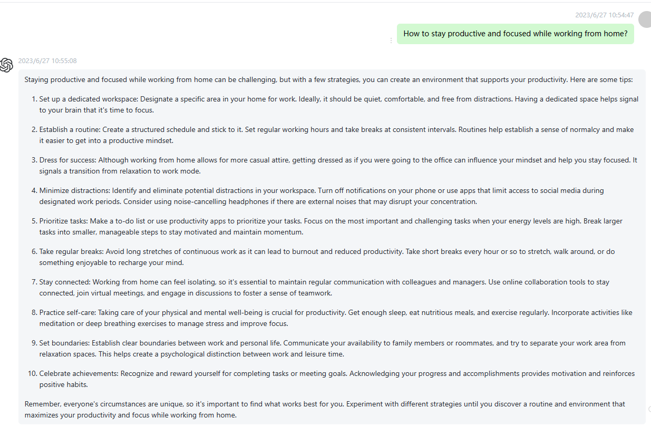

32 What are the ethical issues in artificial intelligence (AI) and how to address them? Please highlight the important words to the semantic meanings in every sentence using boldface fonts.

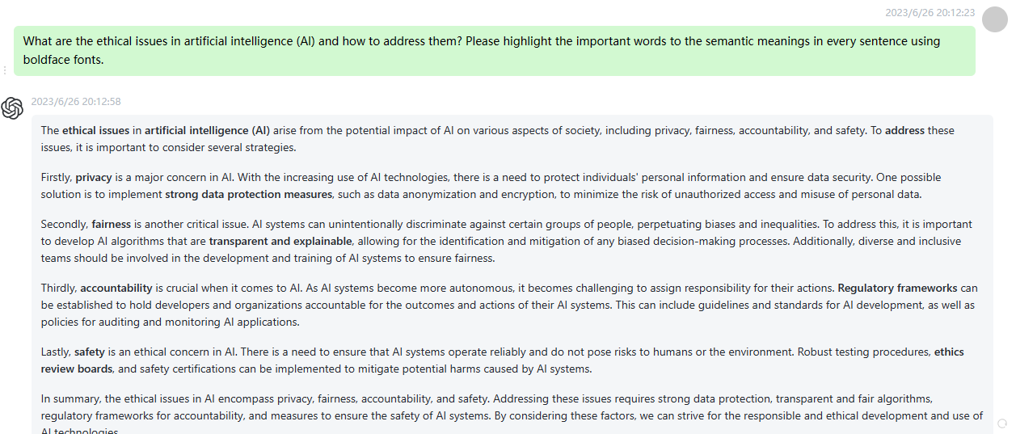

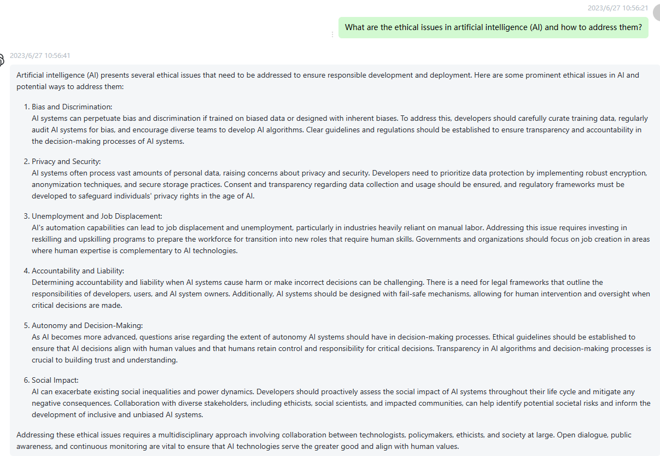

33 How to improve leadership and management skills? Please highlight the important words to the semantic meanings in every sentence using boldface fonts.

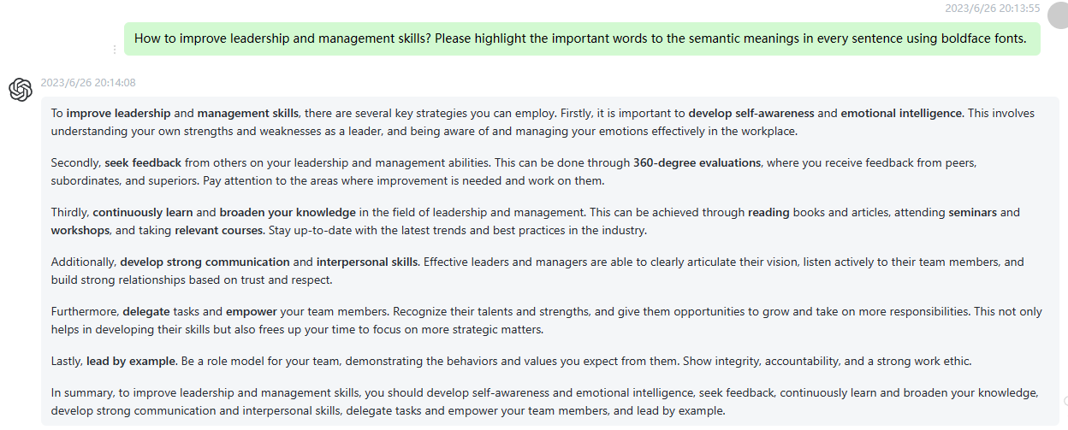

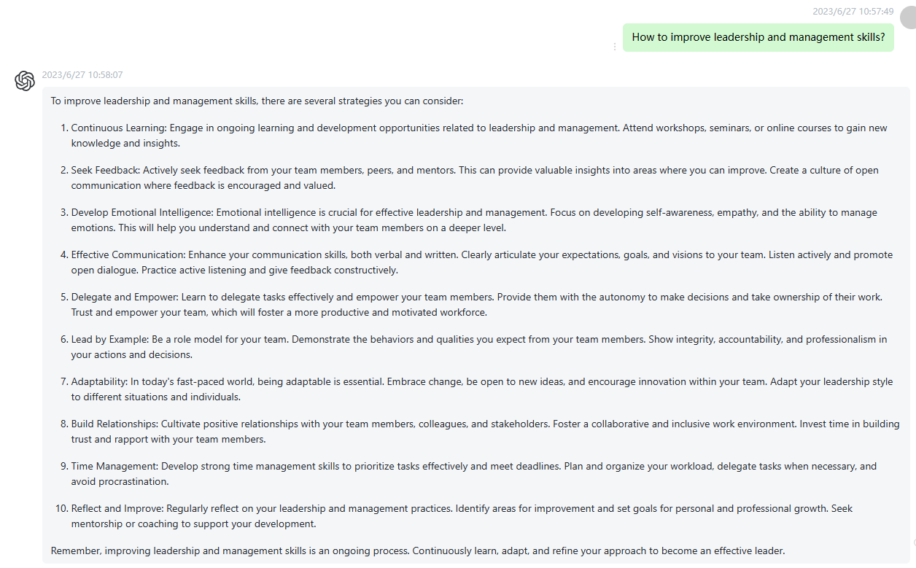

34 How to set realistic and achievable goals, and accomplish them? Please highlight the important words to the semantic meanings in every sentence using boldface fonts.

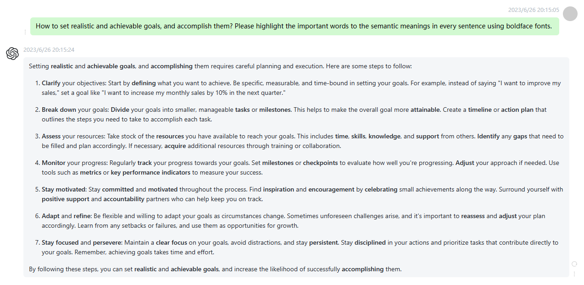

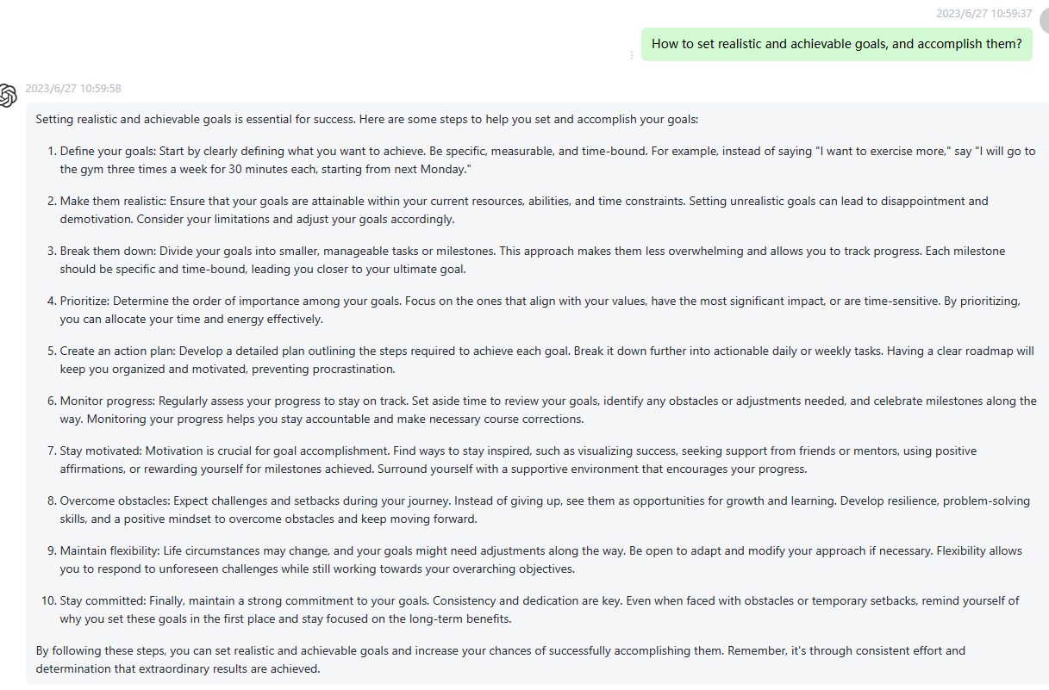

35 What methods can help improve personal decision-making abilities? Please highlight the important words to the semantic meanings in every sentence using boldface fonts.

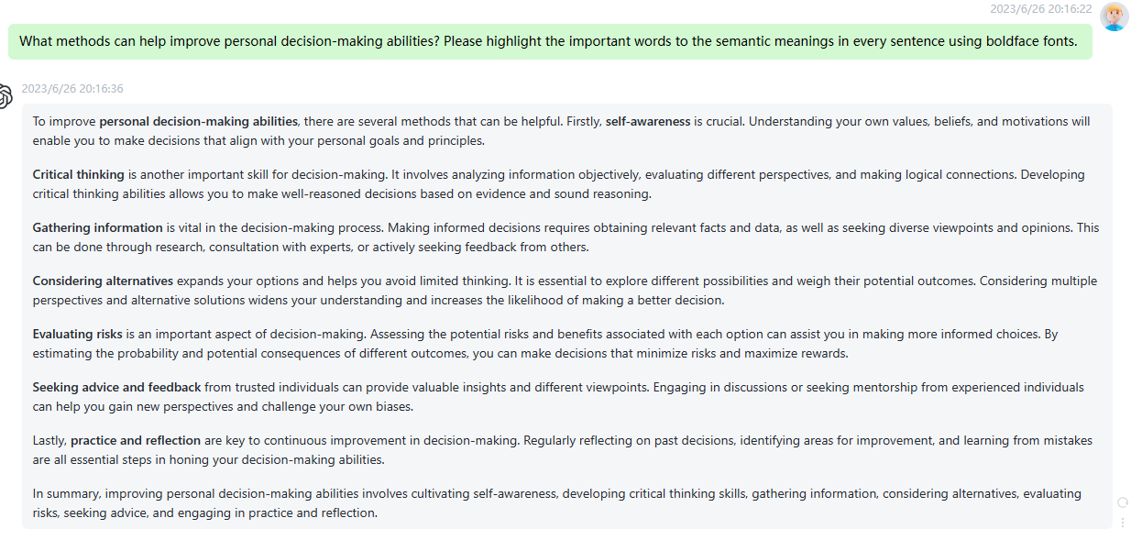

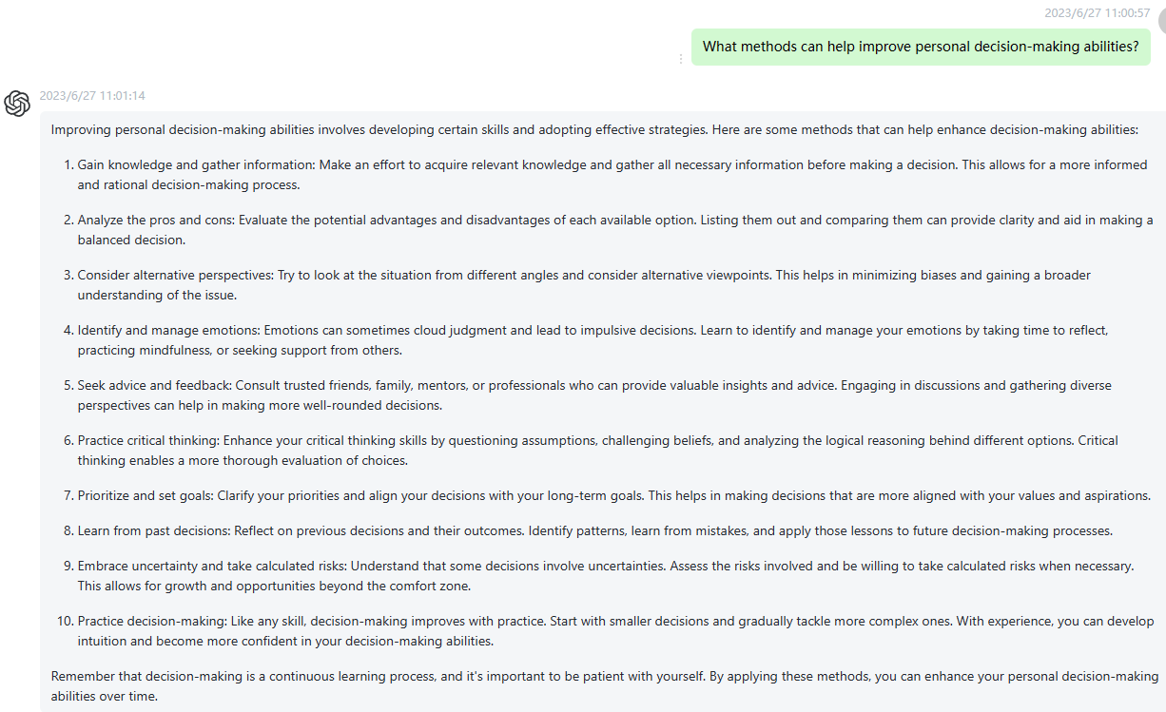

36 How to build self-confidence and overcome social anxiety in social situations? Please highlight the important words to the semantic meanings in every sentence using boldface fonts.

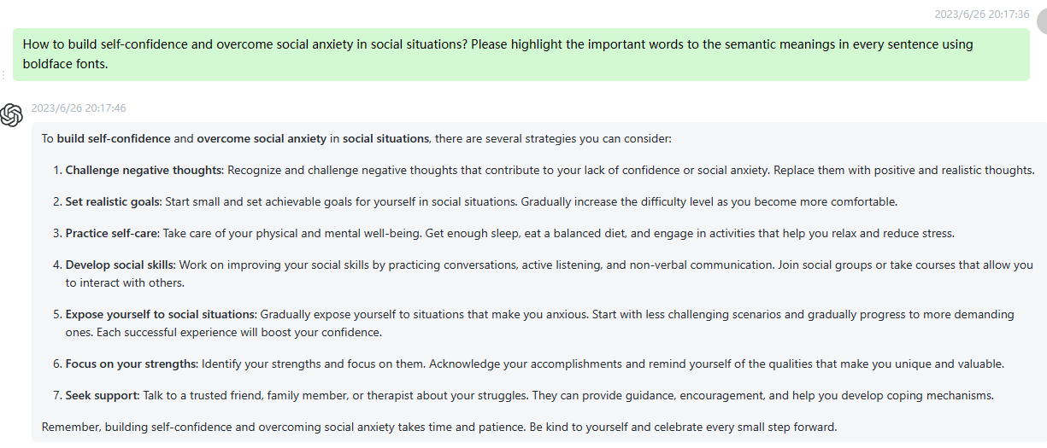

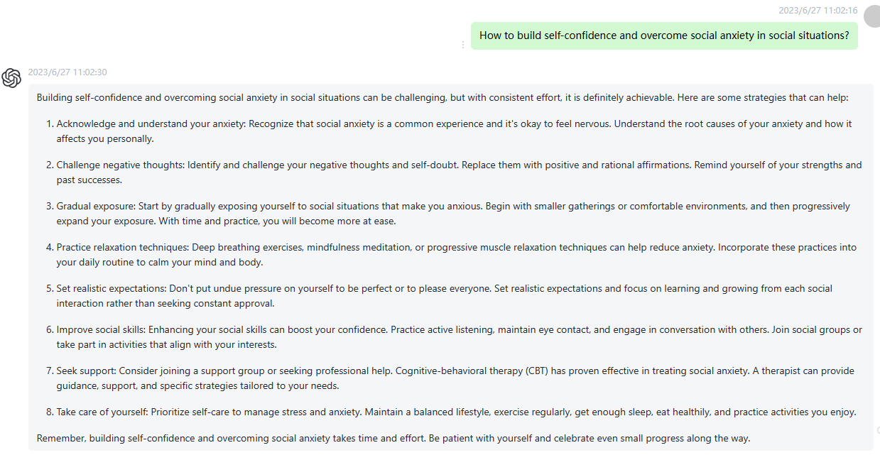

37 How to develop entrepreneurial spirit and innovation capabilities? Please highlight the important words to the semantic meanings in every sentence using boldface fonts.

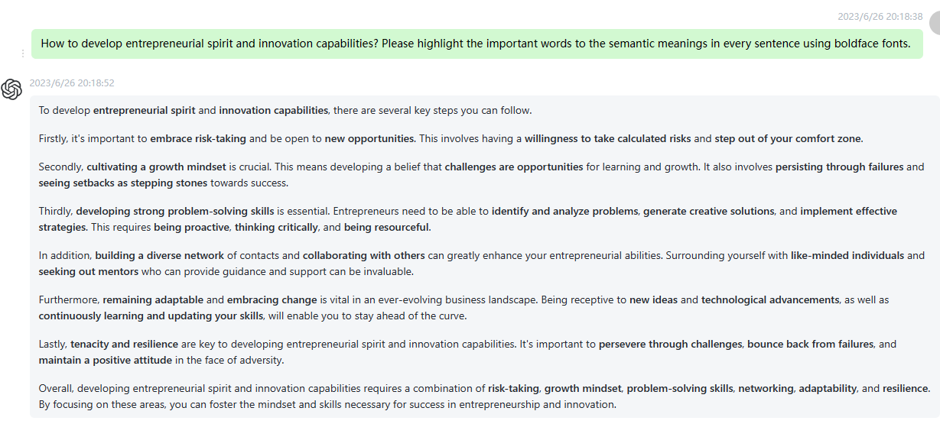

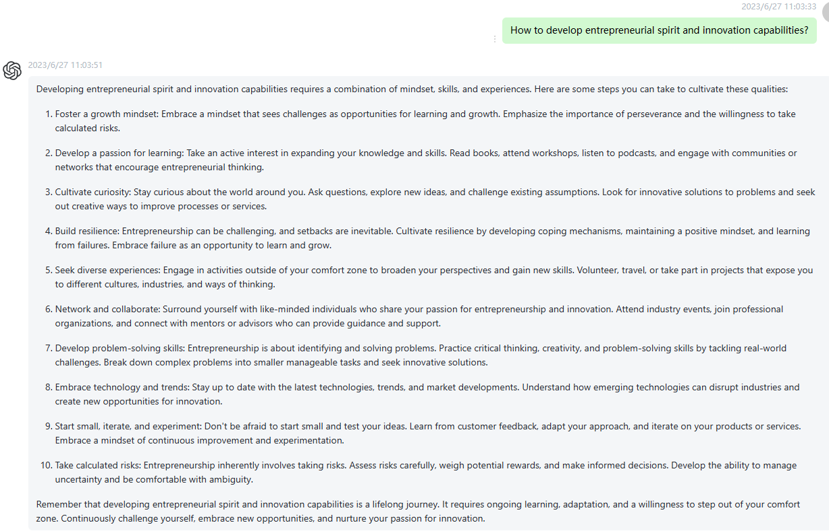

38 What techniques can help enhance public speaking and communication skills? Please highlight the important words to the semantic meanings in every sentence using boldface fonts.

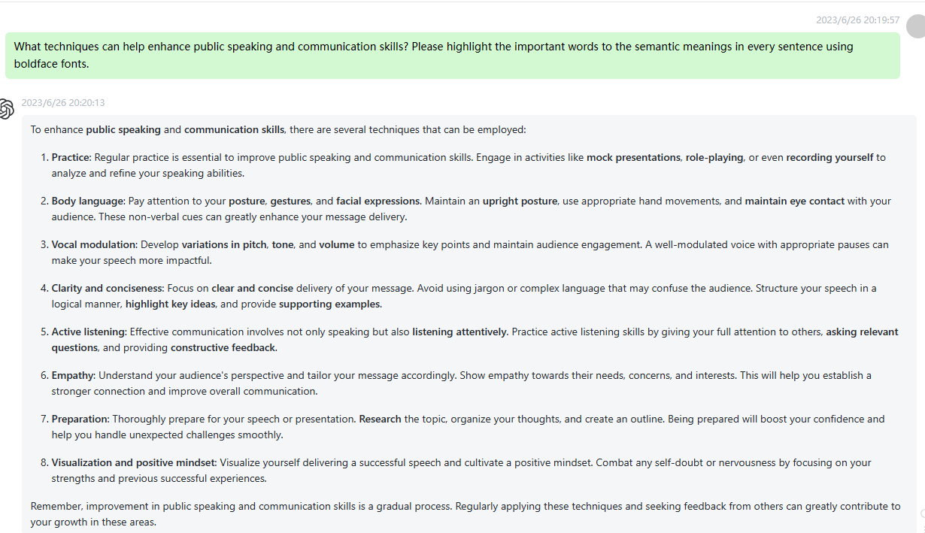

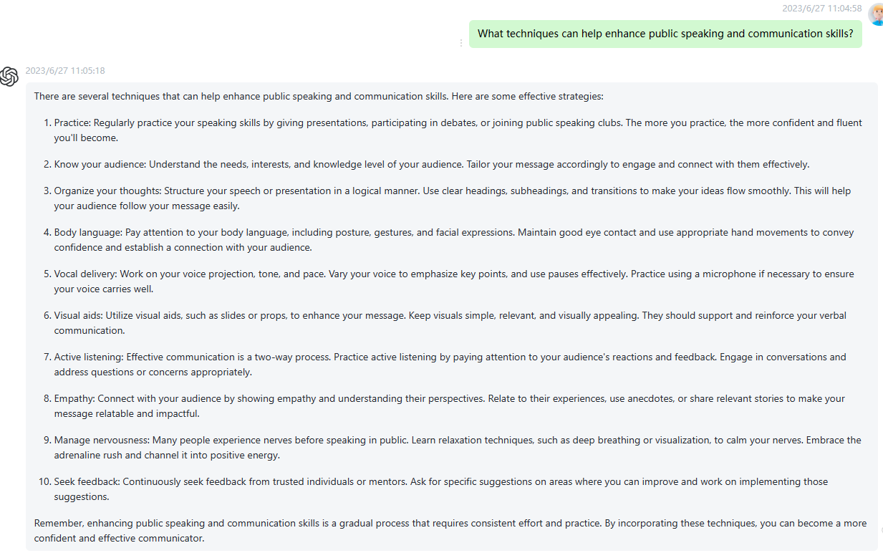

39 How to resolve conflicts and build harmonious relationships within a team? Please highlight the important words to the semantic meanings in every sentence using boldface fonts.

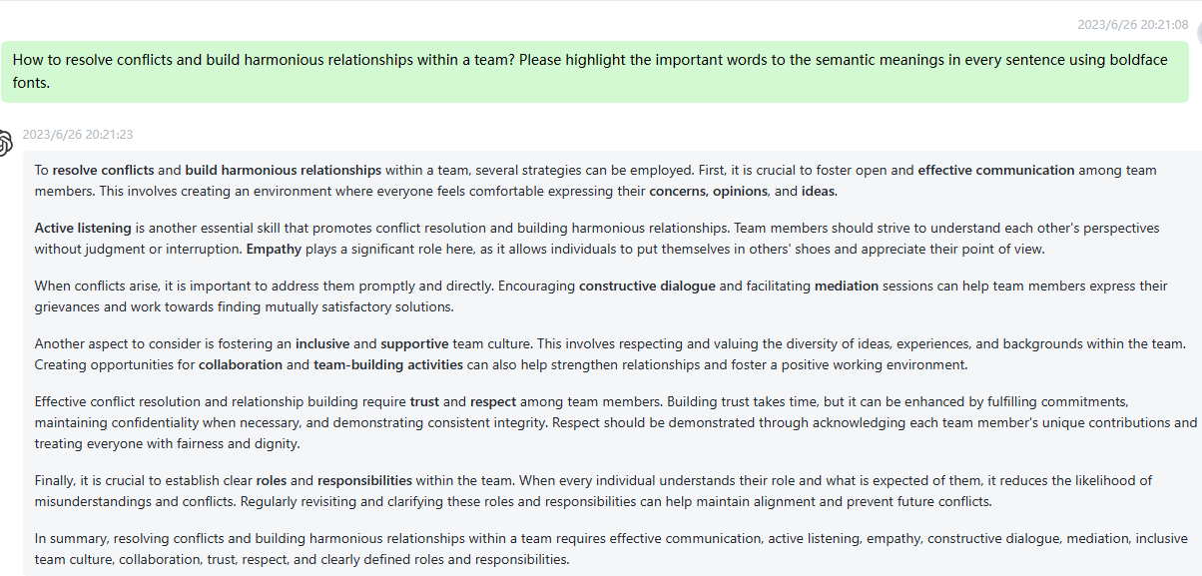

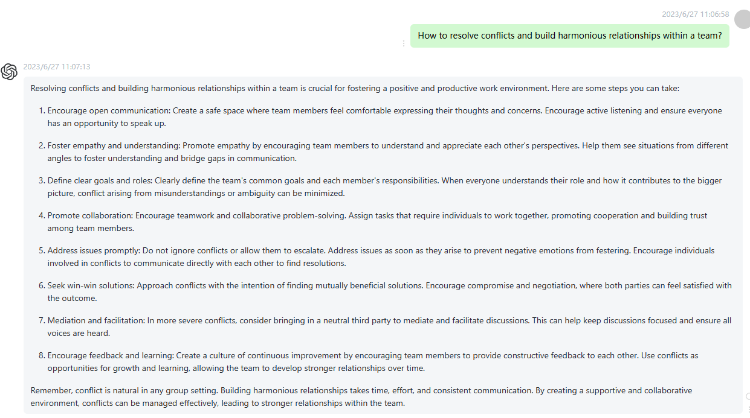

40 What is blockchain technology and what are its potential applications across different industries? Please highlight the important words to the semantic meanings in every sentence using boldface fonts.

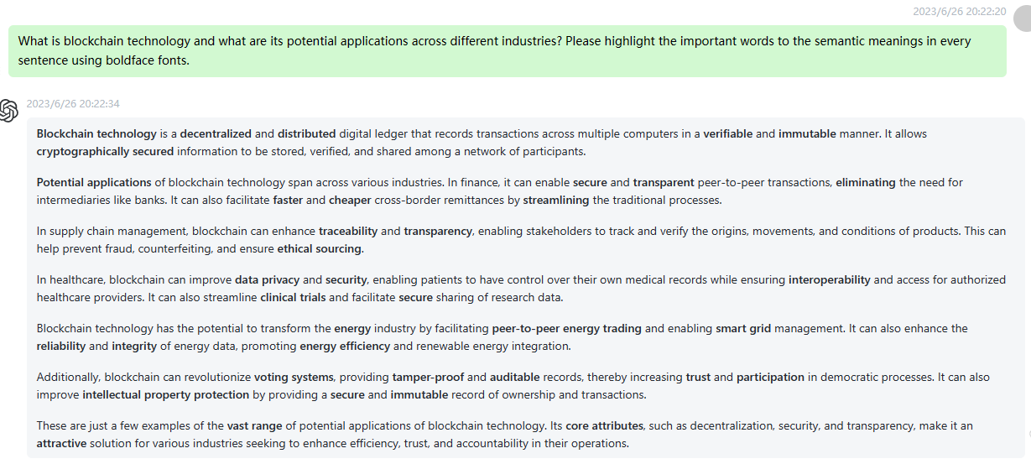

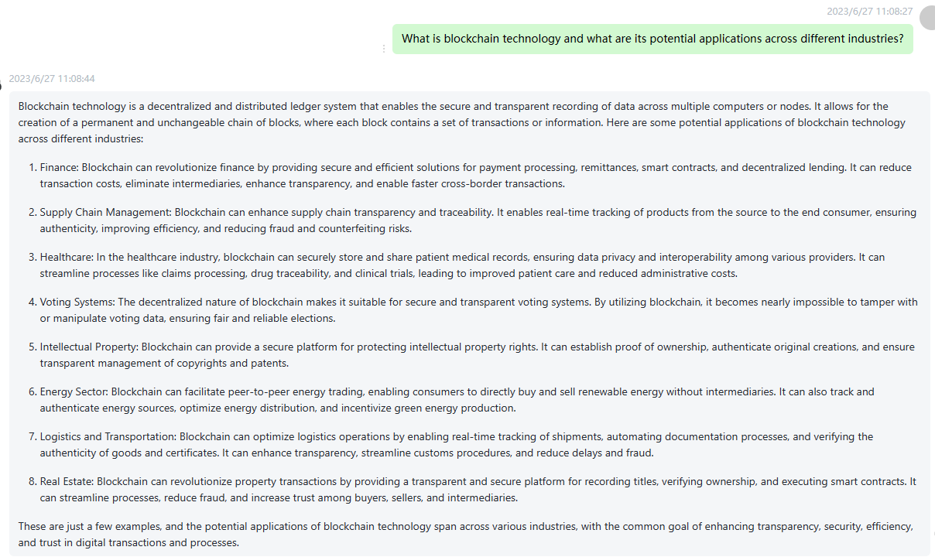

41 How to effectively protect personal identity and prevent identity theft in the digital age? Please highlight the important words to the semantic meanings in every sentence using boldface fonts.

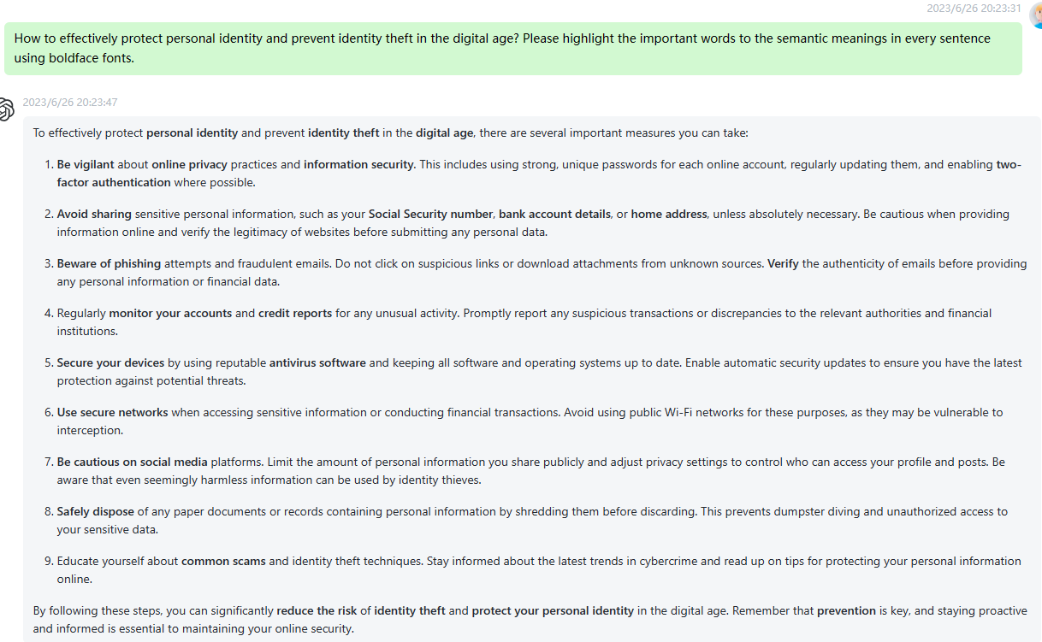

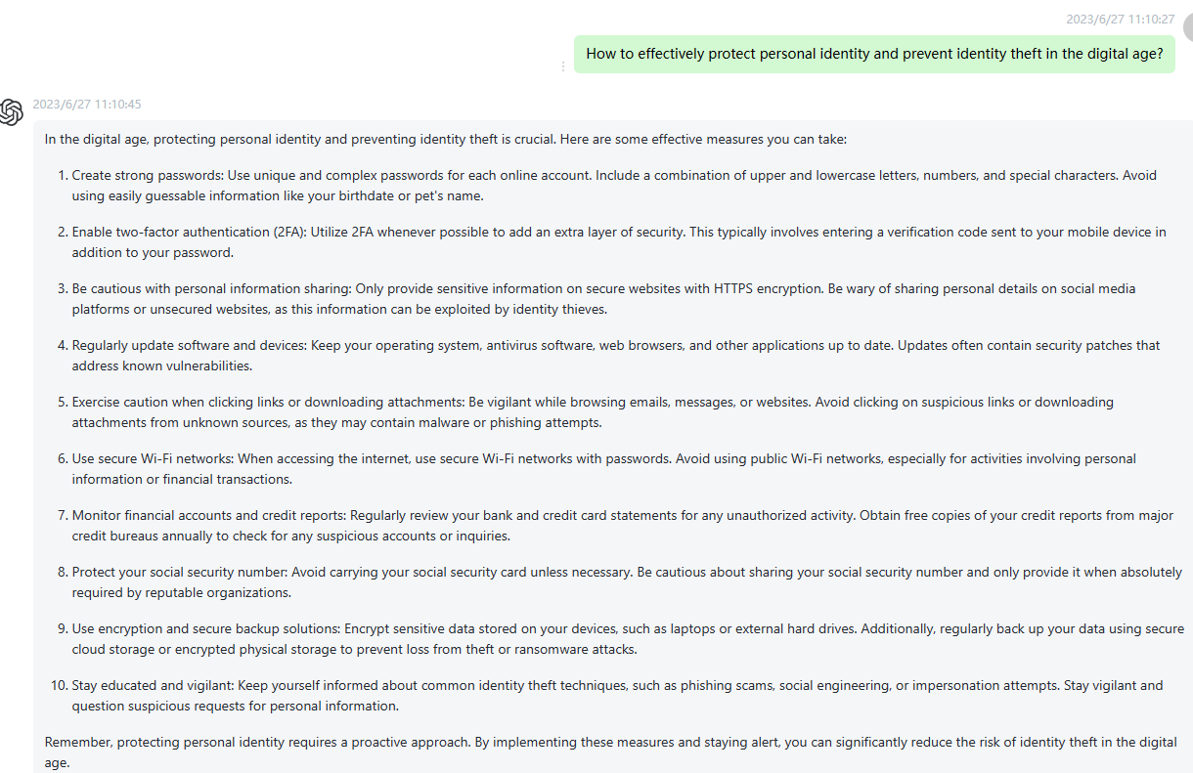

42 How to cope with work stress and overload effectively? Please highlight the important words to the semantic meanings in every sentence using boldface fonts.

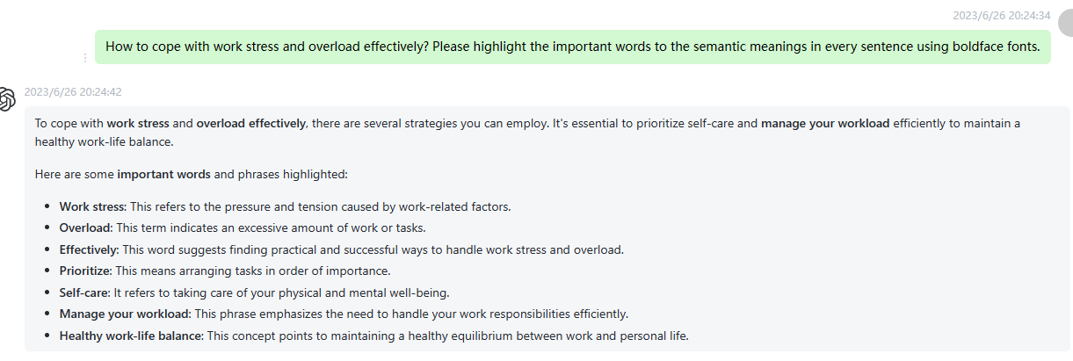

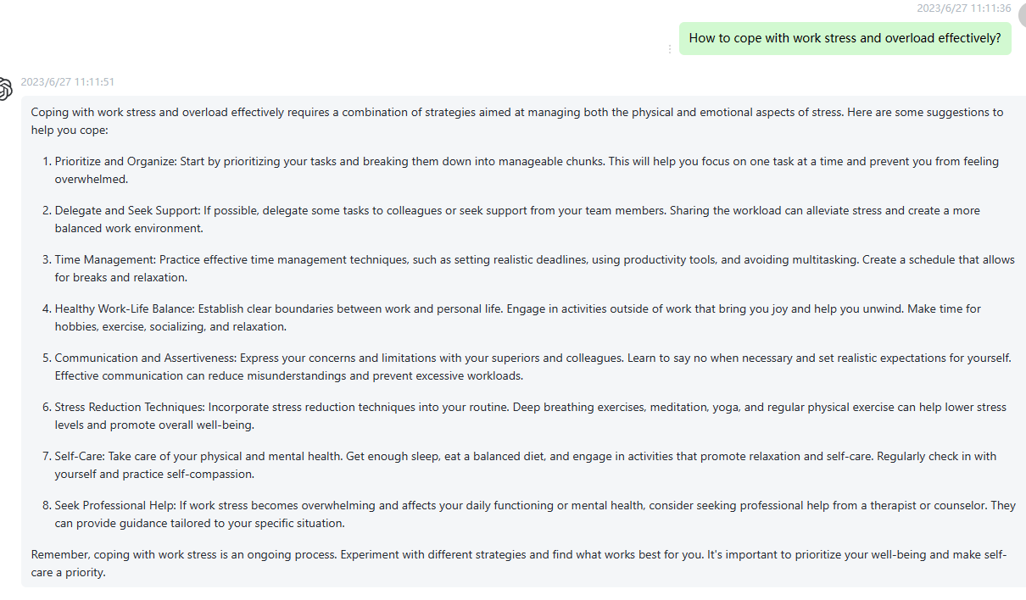

43 What skills can help improve negotiation skills and achieve better agreements? Please highlight the important words to the semantic meanings in every sentence using boldface fonts.

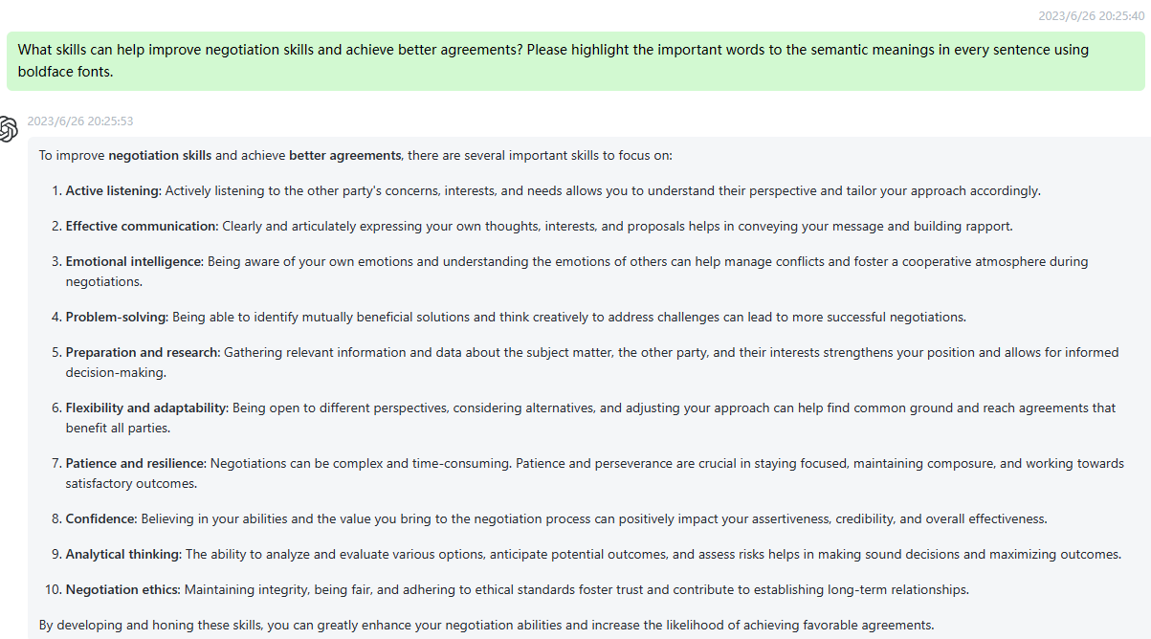

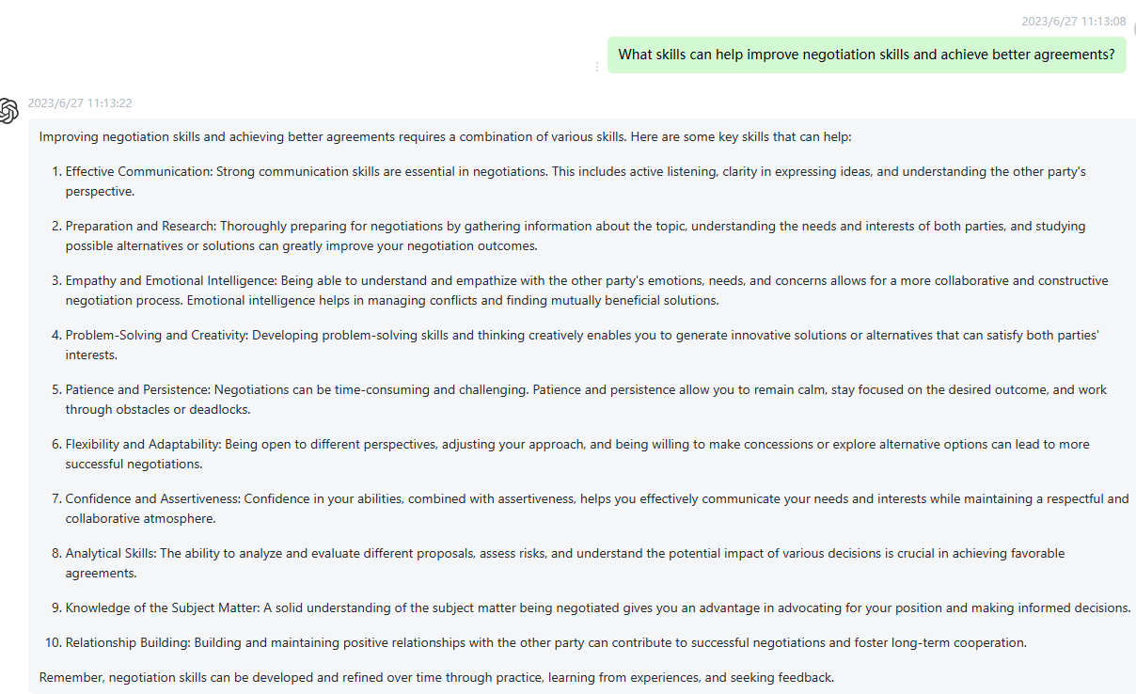

44 How to cultivate creative thinking and drive innovation? Please highlight the important words to the semantic meanings in every sentence using boldface fonts.

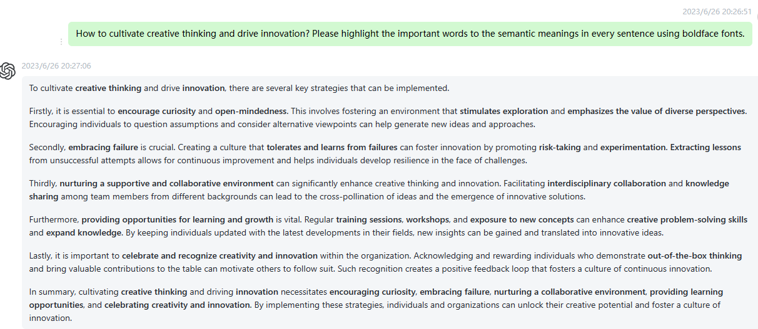

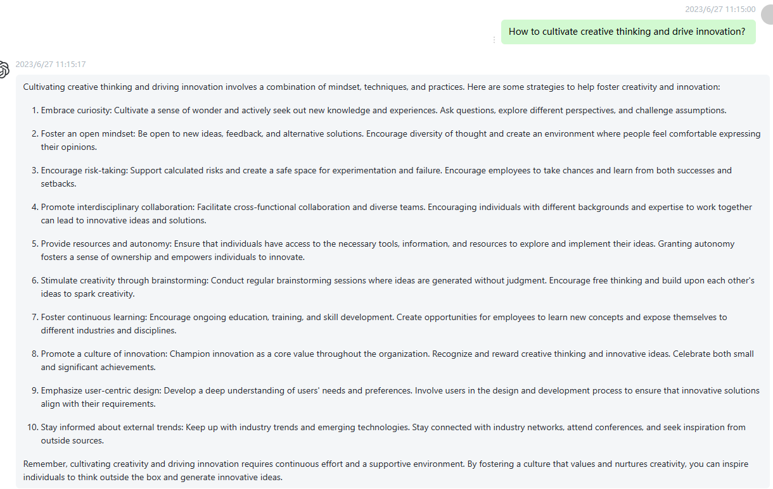

45 How to maintain a positive mindset in the face of setbacks and challenges? Please highlight the important words to the semantic meanings in every sentence using boldface fonts.

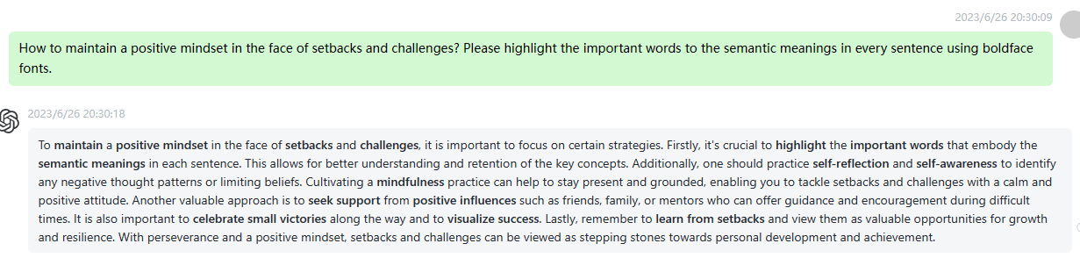

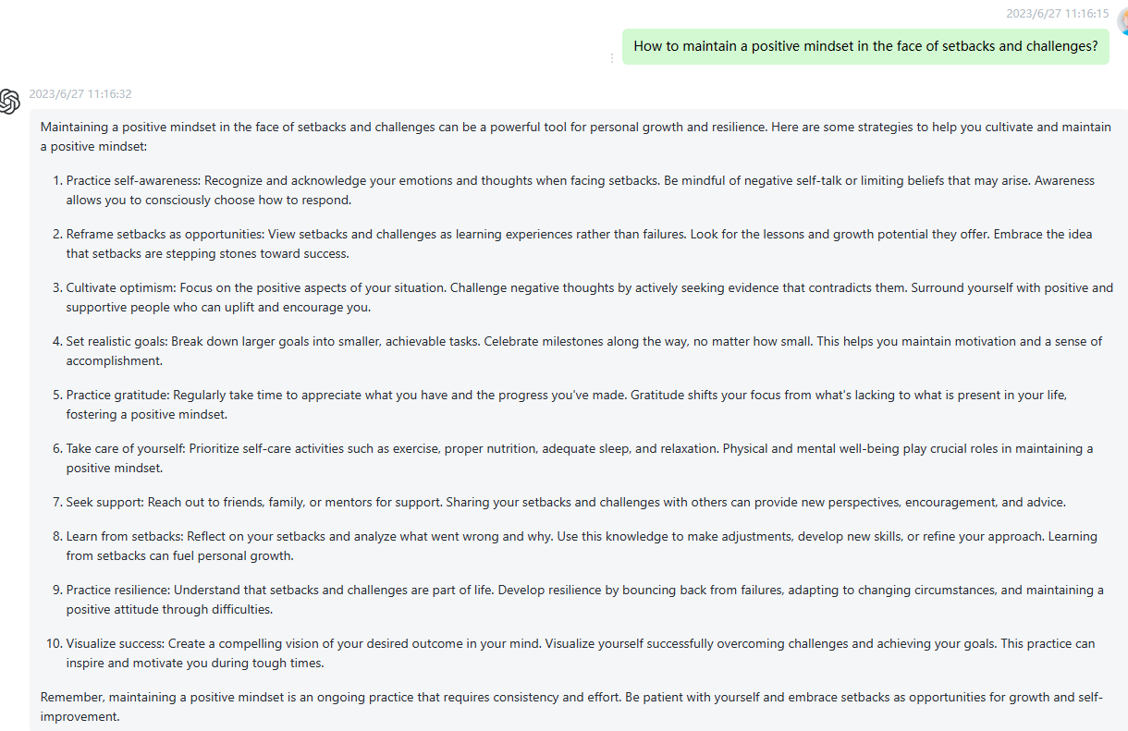

46 What is big data analytics and how is it applied in business decision-making? Please highlight the important words to the semantic meanings in every sentence using boldface fonts.

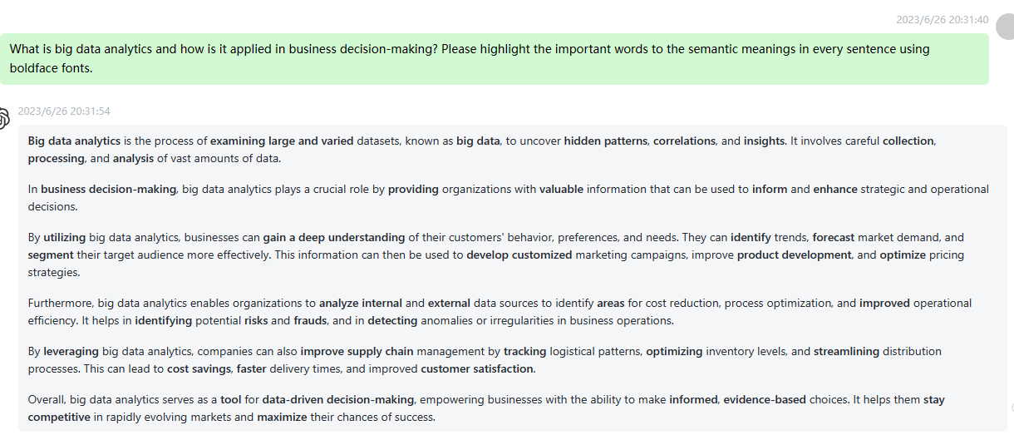

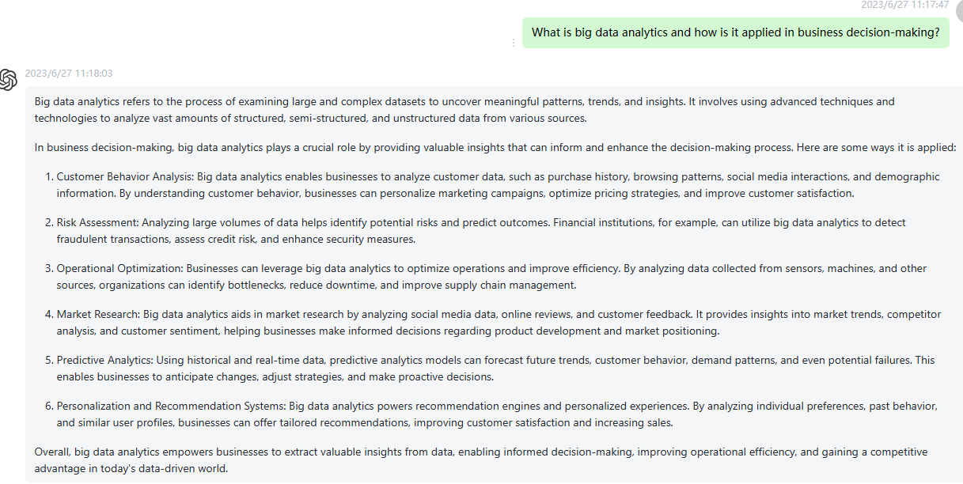

47 How to make personal contributions to environmental conservation? Please highlight the important words to the semantic meanings in every sentence using boldface fonts.

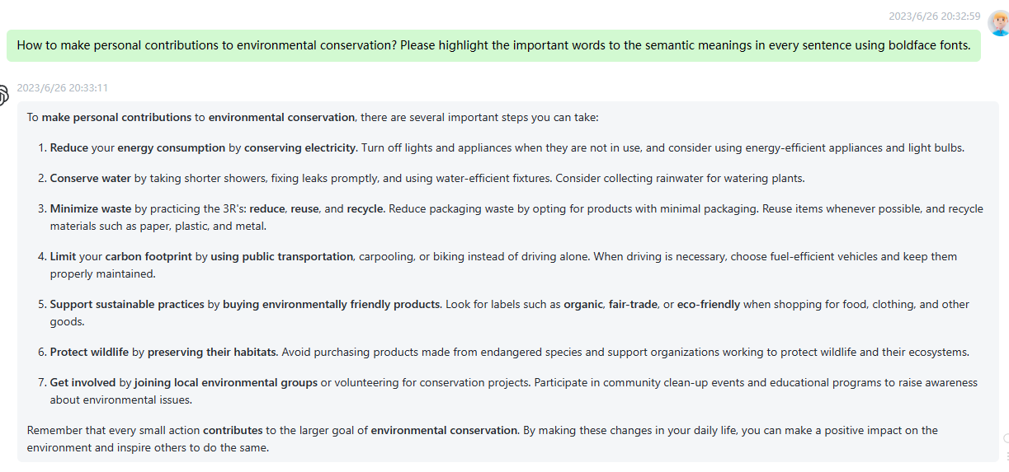

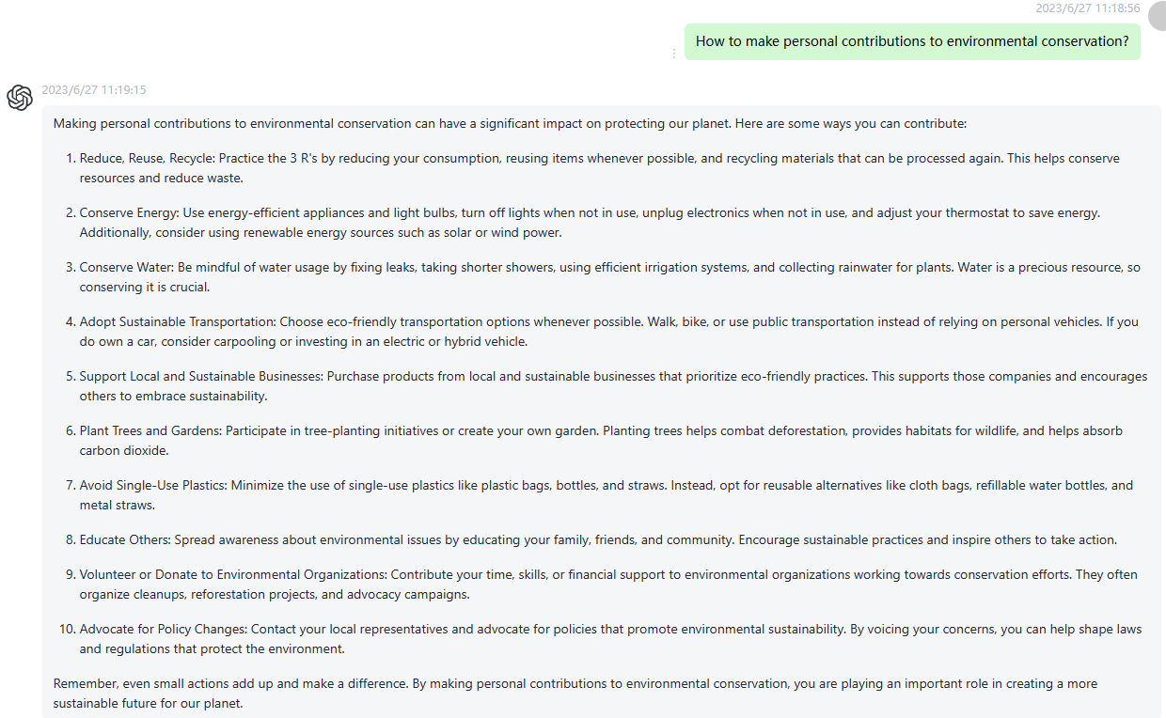

48 How to enhance teamwork collaboration and collective intelligence? Please highlight the important words to the semantic meanings in every sentence using boldface fonts.

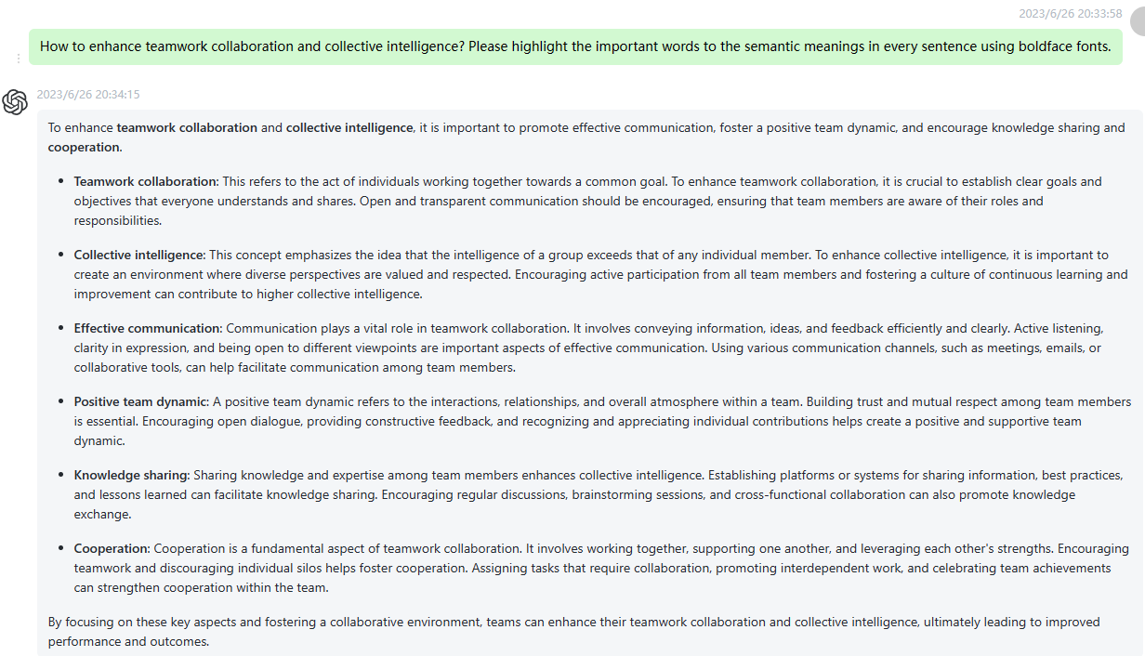

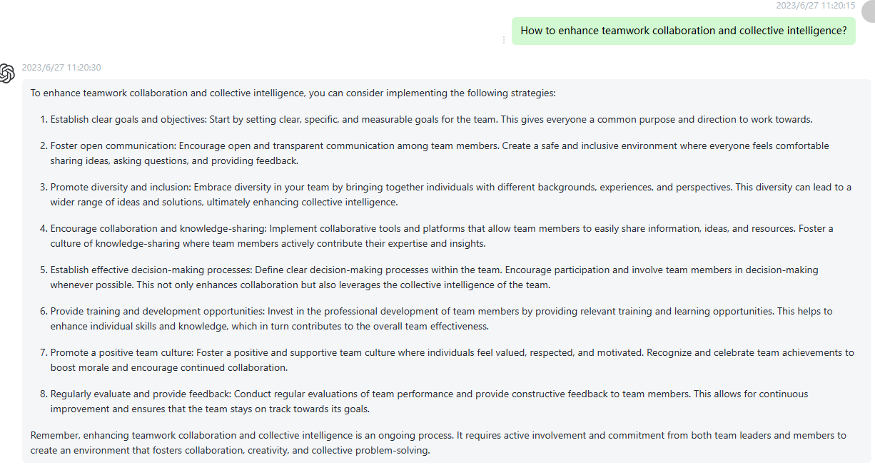

49 What skills contribute to improving self-learning ability and continuous learning? Please highlight the important words to the semantic meanings in every sentence using boldface fonts.

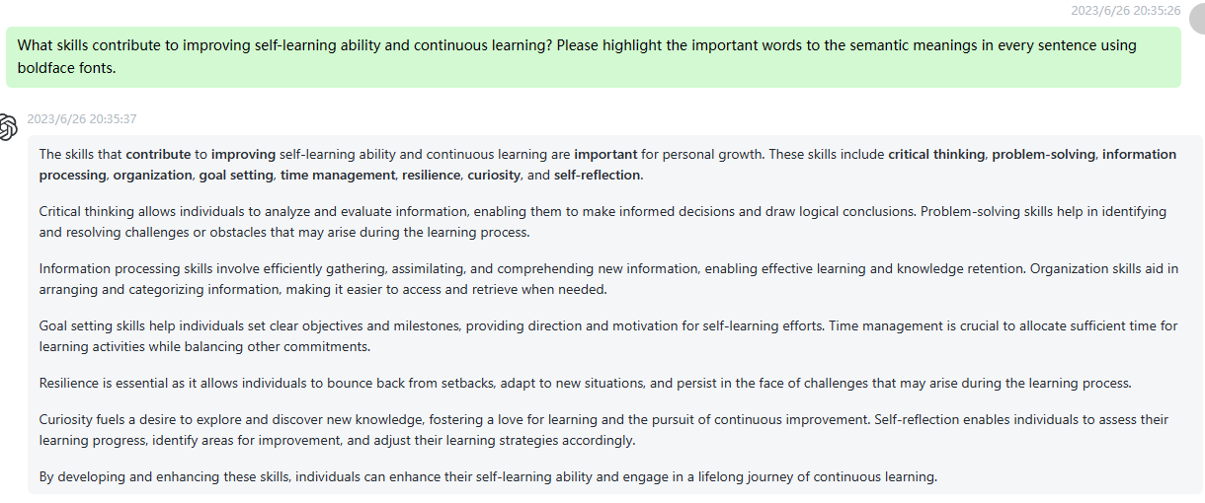

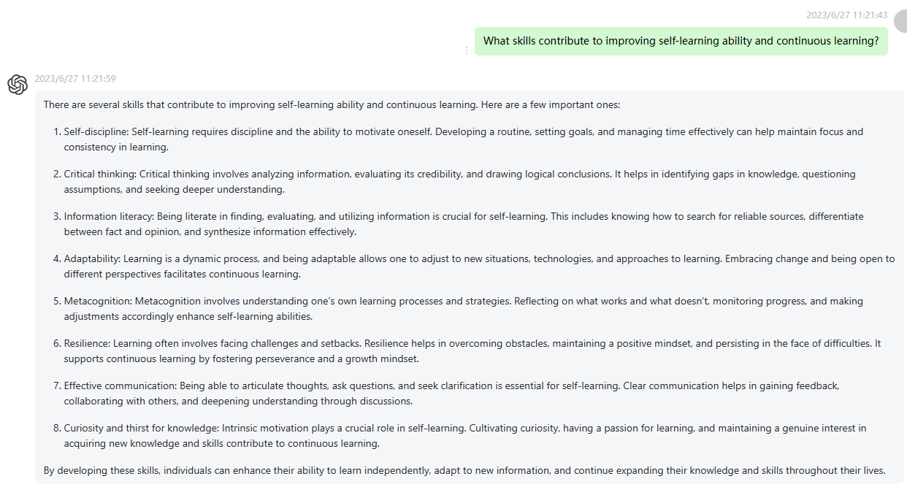

50 How to handle emergencies effectively and respond to crises? Please highlight the important words to the semantic meanings in every sentence using boldface fonts.

